FOR IMMEDIATE RELEASE

Contact: Tom Evans
tom@evanscommunications.com
602.448.5483

New Retail Building Added to SkySong Project

10,500-Square-Foot Structure Will Enhance Mixed-Use Vision for Property

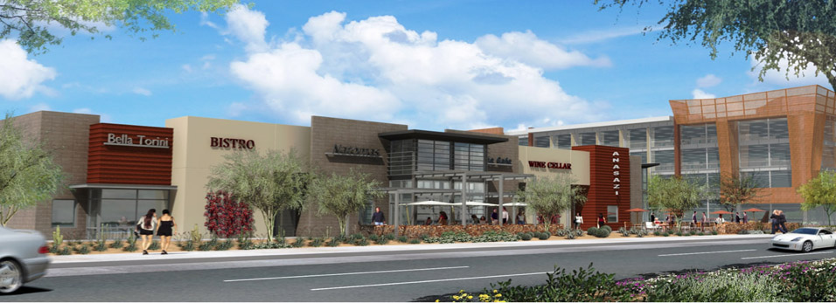

SCOTTSDALE, Arizona (April 30, 2014) — Going out to dinner in southern Scottsdale? Pretty soon, you may just be going to SkySong.

SkySong, The ASU Scottsdale Innovation and its development team are now leasing a planned 10,500 square foot retail building to be built on the northeast corner of Scottsdale Road and SkySong Boulevard.

The new retail building should attract new restaurants and stores to the area to serve the employees and residents on the SkySong property, as well as southern Scottsdale residents as a whole. It’s part of the overall mixed-use vision for SkySong, which will include 1.2 million square feet of development when completed.

It’s also the latest addition to the growing project, which recently saw the completion of the SkySong Apartments and is nearing the completion of SkySong 3, the third office building at the property.

Sharon Harper, President & CEO of Plaza Companies, the master developer of the project, said that the retail building was added to the project because of demand from both those working and living at SkySong and those in the surrounding area.

“We kept hearing from people that they wanted more restaurant and retail options to be a part of the future of SkySong, and this will help us accomplish that goal,” Harper said. “We have a wonderful café on site and have had smaller retail presences in the past, but this will truly bring back strong, established retail to this property and provide some great services for the area.”

SRS Real Estate Partners is handling the leasing for the retail building, which will include adjacent surface parking for use of visitors to the restaurants and stores. The SRS Real Estate Partners team working on SkySong’s retail is Ed Beeh, Chuck Gibson and Robbie Petty.

“The Scottsdale and McDowell Road location is a superb and vibrant location for the regional workforce and area residents,” Beeh said. “It is a high-profile and active intersection, which we believe will make it extremely attractive to unique and local restaurants and stores.”

“We are already seeing interest from retailers who want to be part of the dynamic SkySong vision,” Harper said. “We’re looking forward to working with them to help provide some great new dining and shopping opportunities for SkySong and the surrounding area.”

SkySong, the ASU Scottsdale Innovation Center is a home to a global business community that links technology, entrepreneurship, innovation, and education to position ASU and Greater Phoenix as global leaders of the knowledge economy.

SkySong is a 42-acre mixed use development designed to:

- Create an ecology of collaboration and innovation among high-profile technology enterprises and related researchers;
- Advance global business objectives of on-site enterprises;
- Raise Arizona’s profile as a global center of innovation through co-location of ASU’s strategic global partners; and
- Create a unique regional economic and social asset.

Companies located at SkySong enjoy a special relationship with Arizona State University, which has more than 73,000 students at four metropolitan Phoenix campuses. Its campus in Tempe is the single largest campus in the U.S., and is located less than three miles from SkySong.

In addition to locating its own innovative research units at the center, ASU provides tenants with direct access to relevant research, educational opportunities and cultural events on its campuses. Through ASU’s on-site operations, tenant companies have a single point of contact for introductions to researchers, faculty and programs to address their specific needs.

For more information on SkySong, visit www.skysongcenter.com or www.facebook.com/skysongcenter.

— 30 —

ABOUT THE SKYSONG TEAM

Plaza Companies is the developer of the project in partnership with Arizona State University Foundation and the City of Scottsdale. Lee and Associates provides the brokerage services and Plaza del Rio Management Corporation provides the property management and construction services. Architects at SkySong include Pei Cobb Fried and Partners, DMJM Design, Butler Design Group and Kendle Design Collaborative.

With offices in Peoria, Scottsdale and Tucson, Plaza Companies is a full-service real estate firm specializing in the management, leasing and development of medical office and commercial office properties, technology and bioscience facilities, mixed-use properties and senior housing communities. Since 1982, Plaza Companies has established a proud track record as a competitive, connected and conscientious real estate firm with partnerships throughout the industries it serves. For more information, visit www.theplazaco.com.

ABOUT THE ASU FOUNDATION

ASU Foundation is an independent non-profit organization that acts as the principal agent through which gifts are made to benefit the Arizona State University. The mission of the ASU Foundation is to solicit, manage and disburse the proceeds of gifts made to ASU. www.asufoundation.org.

ABOUT HOLUALOA

Holualoa Companies is a real estate investment firm focused on the successful acquisition, repositioning, redevelopment and disposition of real estate assets. Headquartered in Tucson, Arizona, with offices in Phoenix, Santa Monica, Hawaii and Paris, its investments span the United States and Europe and include office, retail, industrial, multi-family, hotel and mixed-use investment properties. Holualoa is an experienced investor for its own account and on behalf of a select group of private investors.

